Phase-4
Develop a Web Application using
frontend stack
Project :-Kitchen Story
(Application Screenshots)

Version History
Author | K.Swathi
Purpose | Screenshots of the Application
Date | 11/12/2021
version | 1.0

1

Table of Content: Pg.No.
Admin Login ............................................................... .......................................................... 3
Orders list............................. .................................................................................................. 3
Admin Home...............................................................................................................................4
View Users...................................................................................................................................4
Add Recipe..................................................................................................................................5
View Recipe.................................................................................................................................6
View Feedback............................................................................................................................7
Users Flows
Web Home page.........................................................................................................................8
View Famous Food Items..........................................................................................................8
View Famous Food Items..........................................................................................................9
Check for Offers.........................................................................................................................9
Special Offers.............................................................................................................................10
User Registration.......................................................................................................................10
User details for Registraion......................................................................................................11
Validating User Form................................................................................................................11
Login Page(after sucessful registration)..................................................................................12
User Login...................................................................................................................................12
User Home...................................................................................................................................13
Search for the Item.....................................................................................................................14
Search for the Item.....................................................................................................................15
Buy Now......................................................................................................................................15
Go to cart to check out...............................................................................................................16
Click on Check out for payment...............................................................................................16
Provide card details(credit/debit).............................................................................................17
Payment Successful page...........................................................................................................17
Order Successful confirmation.................................................................................................18
User Profile Settings...................................................................................................................19
Click on My Profile.....................................................................................................................19
Click on Edit Profile....................................................................................................................19
Edit Profile....................................................................................................................................20
To Change Password .................................................................................................................20
To Change Password .................................................................................................................21
Forgot Password .........................................................................................................................21
Forgot Password .........................................................................................................................22
Feedback ......... .............................................................................................................................22
Contact and Feedback Form ......................................................................................................23
Logout ...........................................................................................................................................24

2

Admin Login
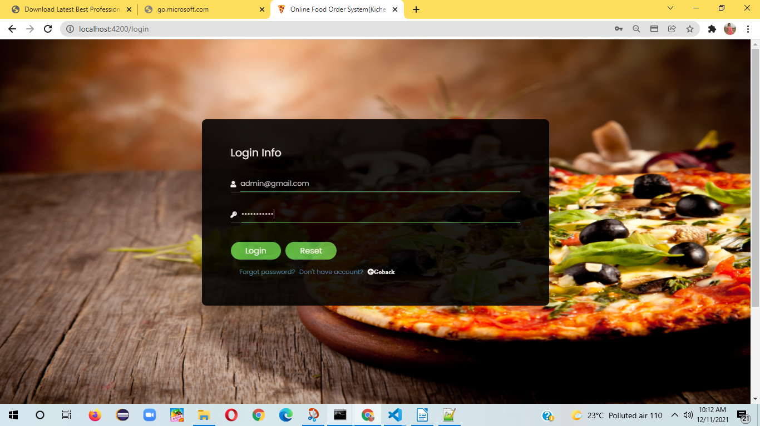
After Logon admin home will display orders list:-
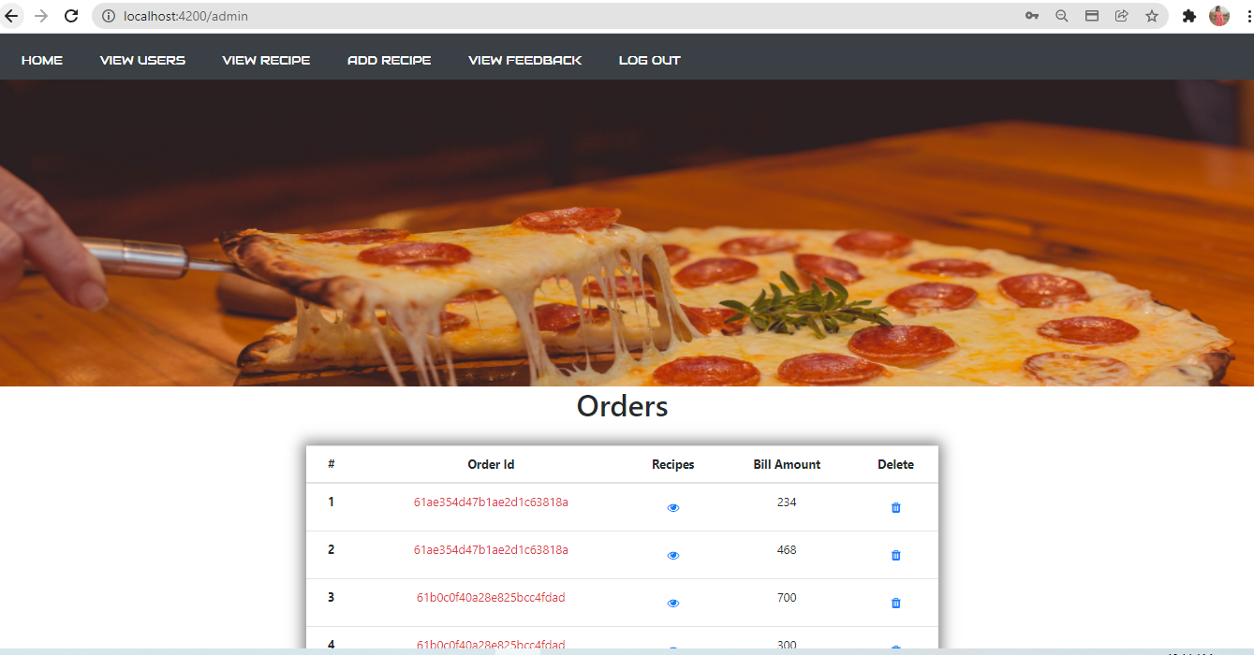
3

Admin Home:
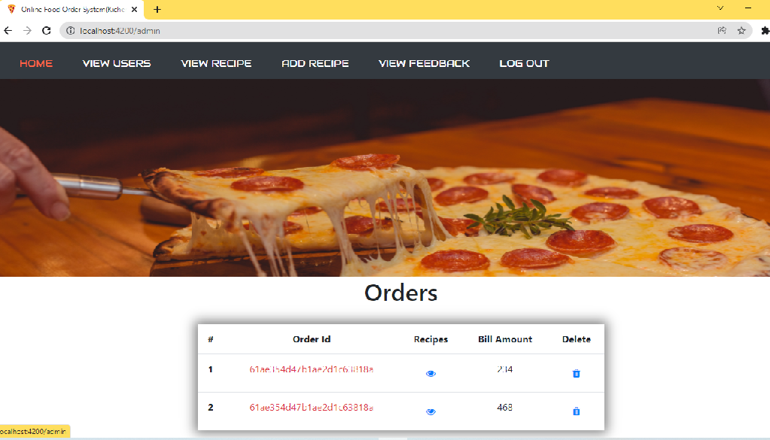
View users:-
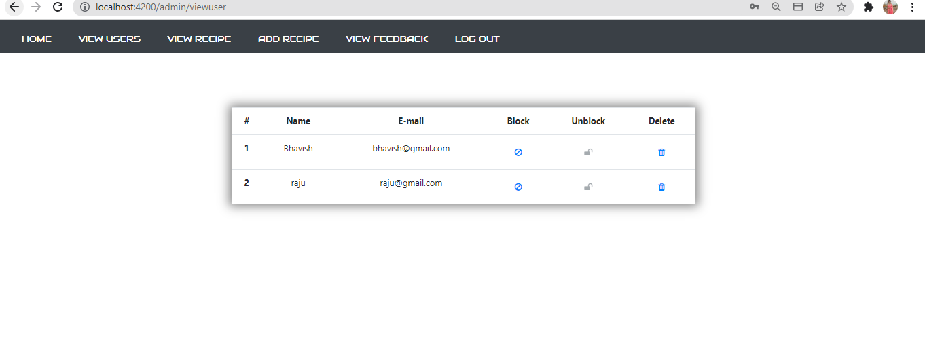

4

Add Recipe
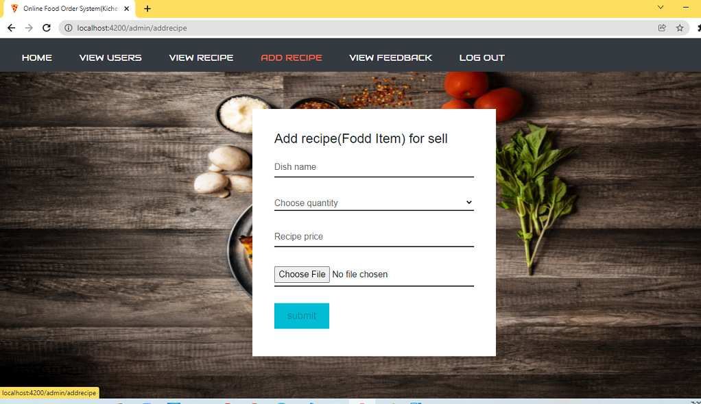
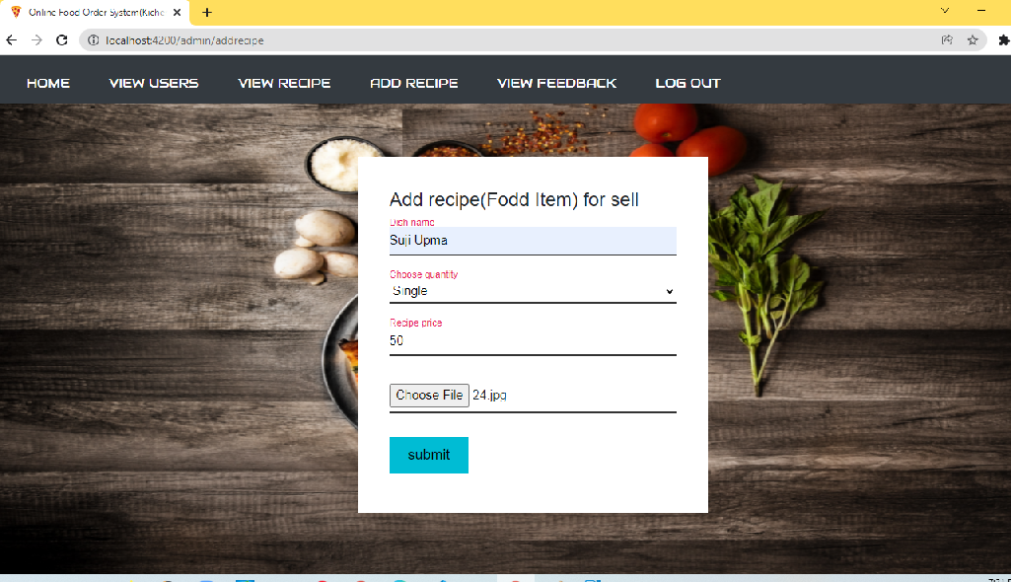

5
view recipe
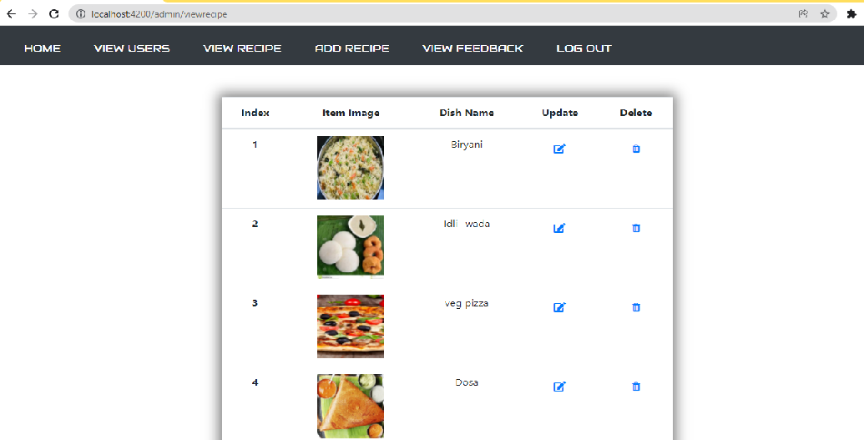

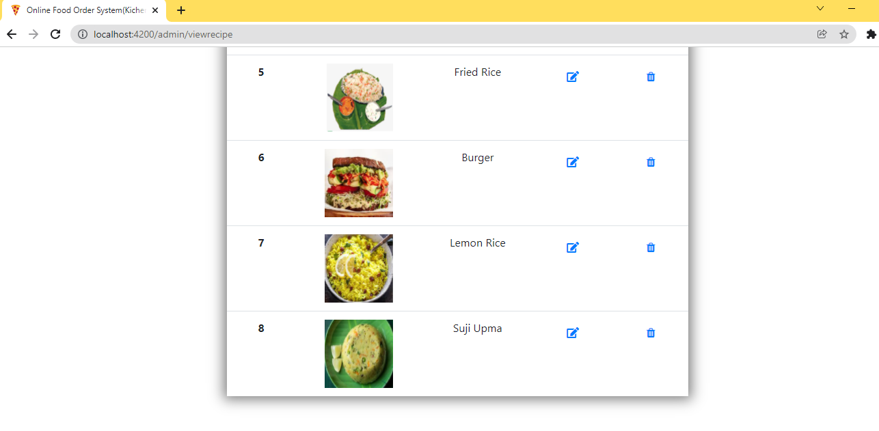
6
View Feed back
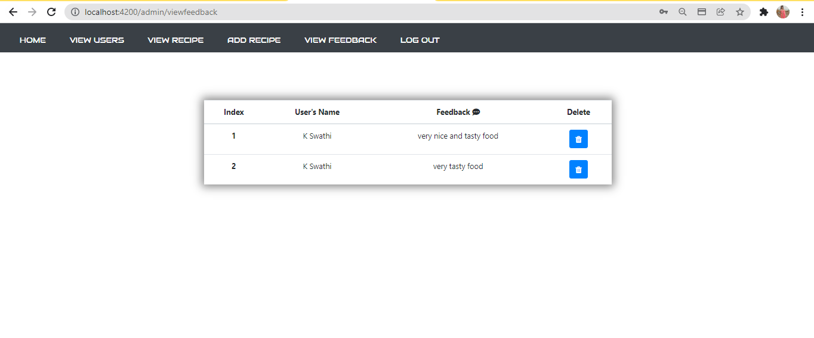

7

User Flows:
1)Web home page
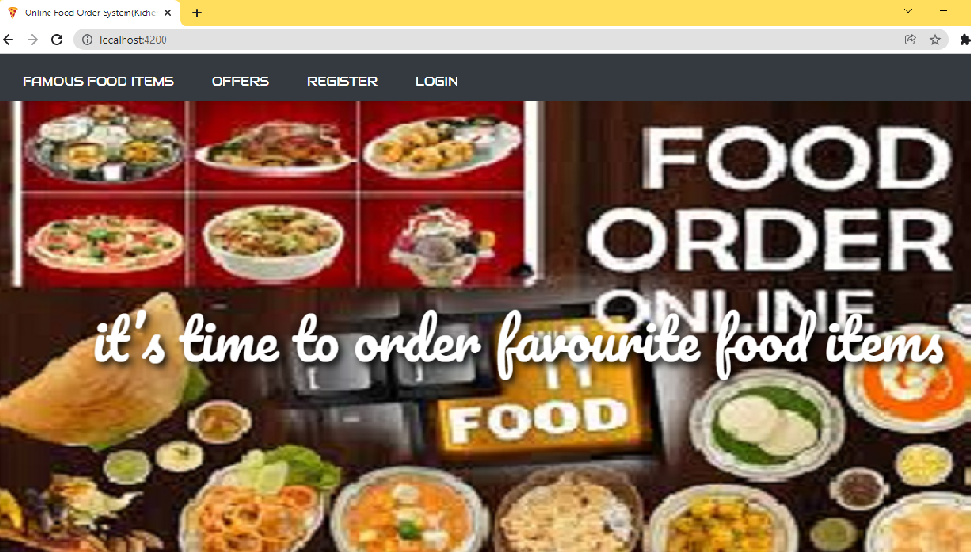
2) View famous food items
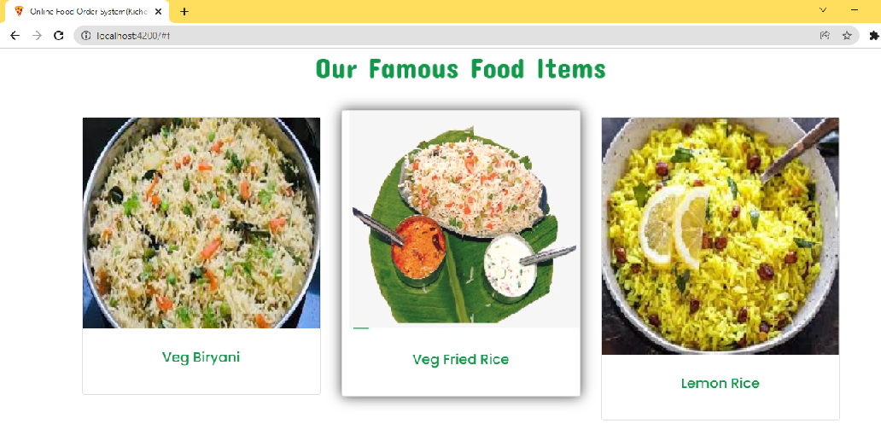

8
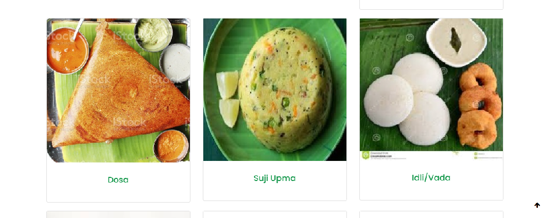

Check for offers
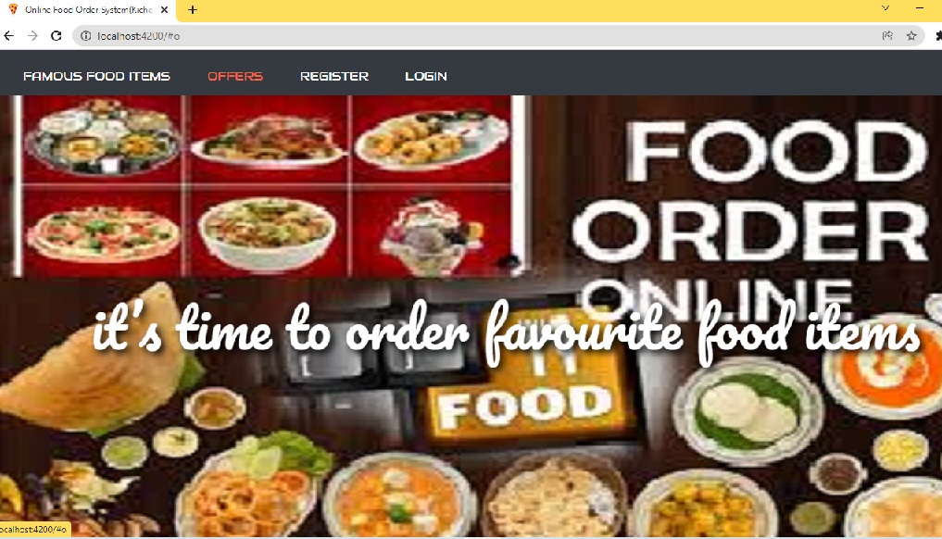

9
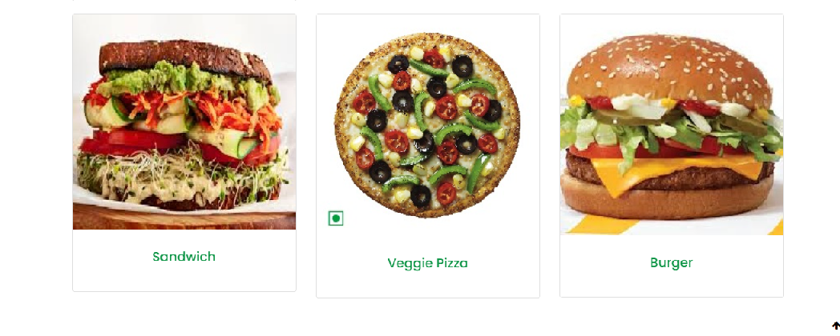
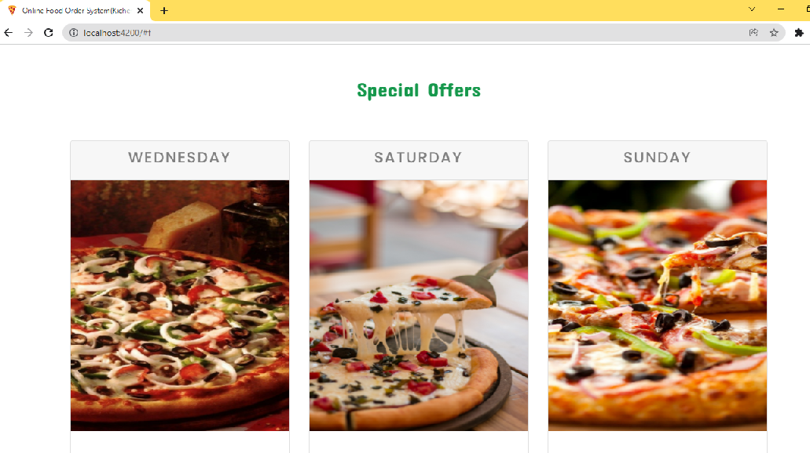
User Registration (click on register)

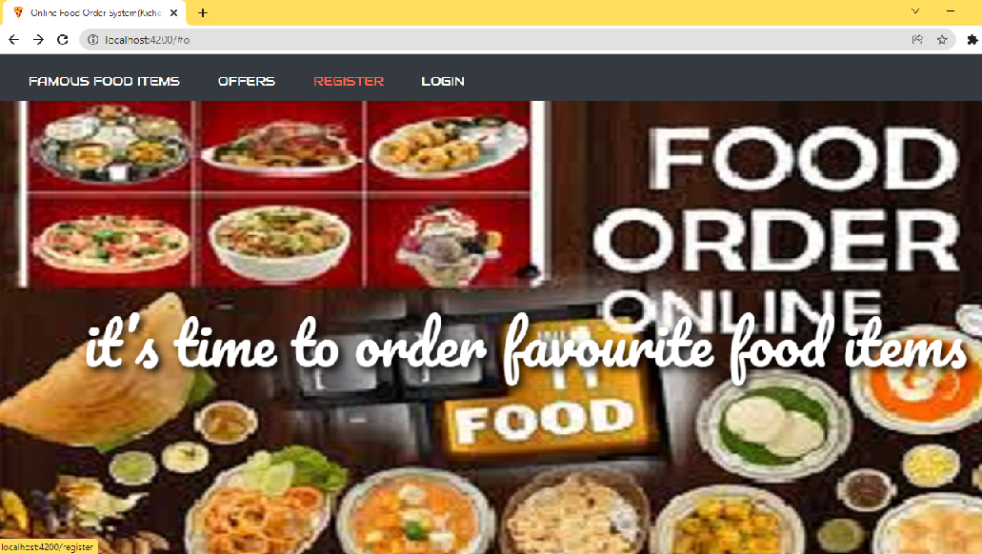

10

Provide User details for Registration
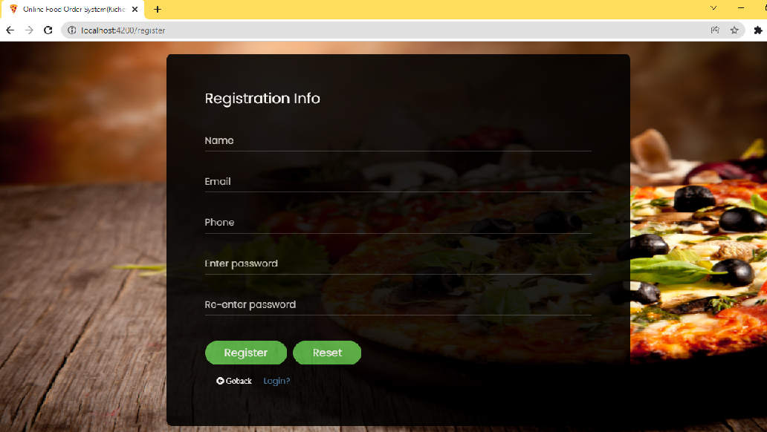
Validating user form:

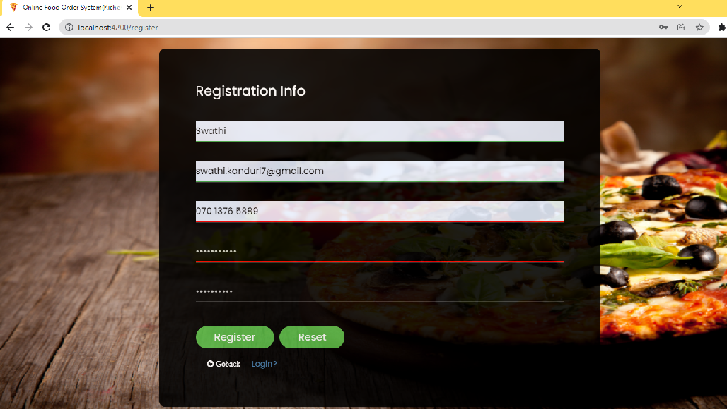
11

After Successful Registration it will redirect to login page

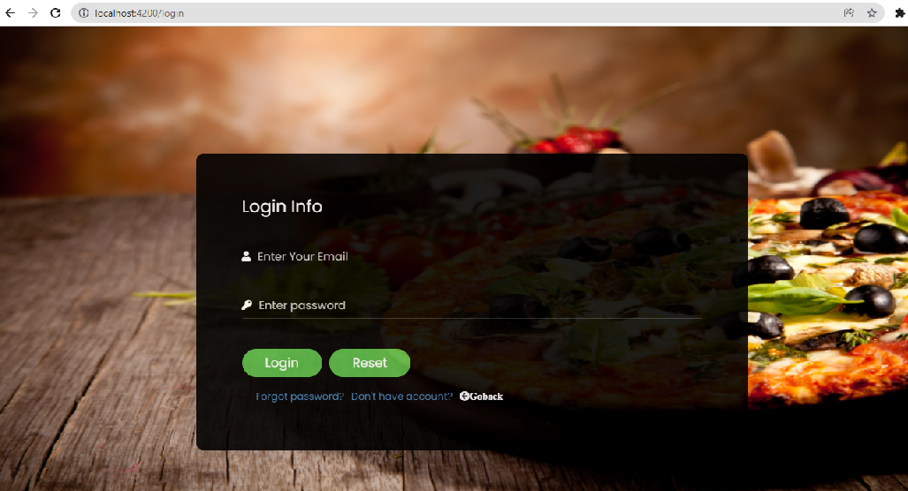
User Login:-
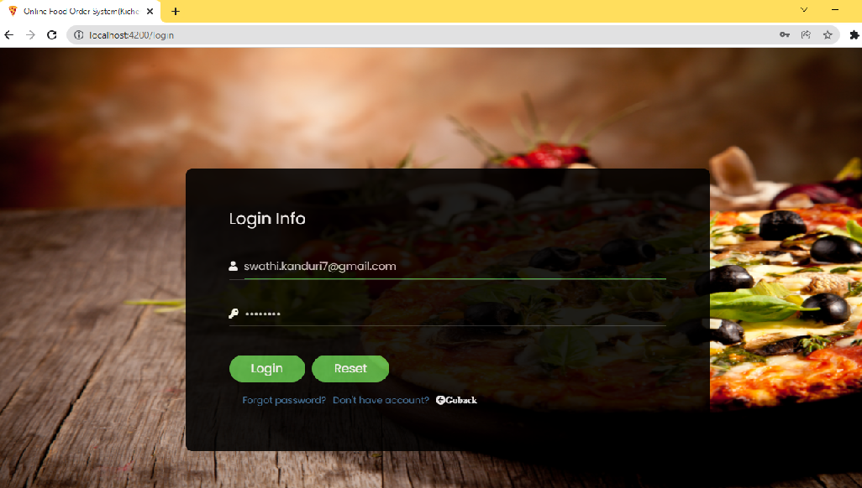
12

User Home
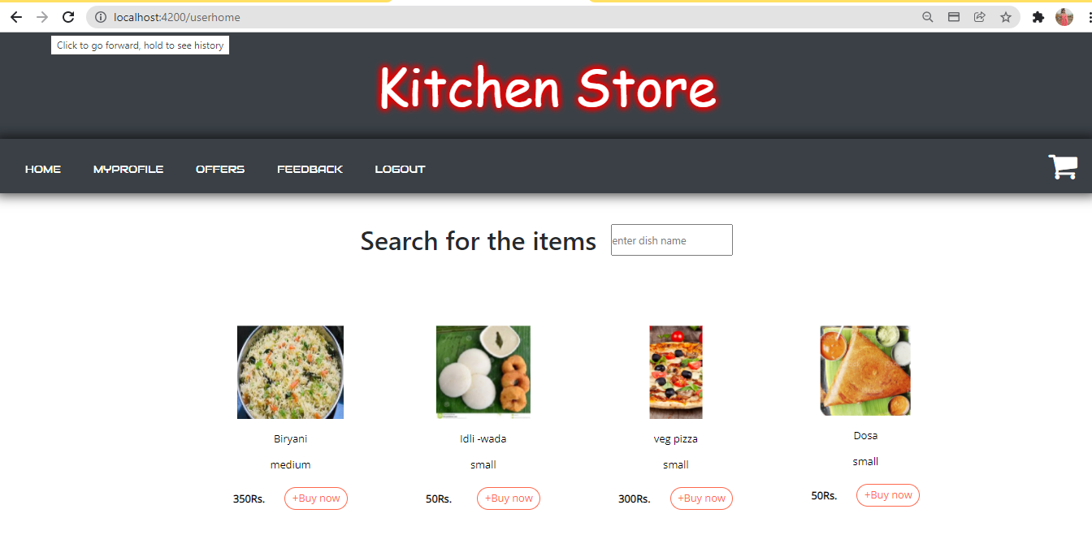

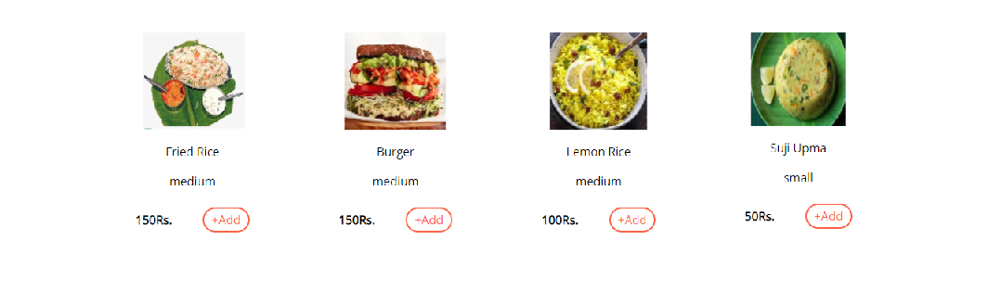

13

Search for the items:
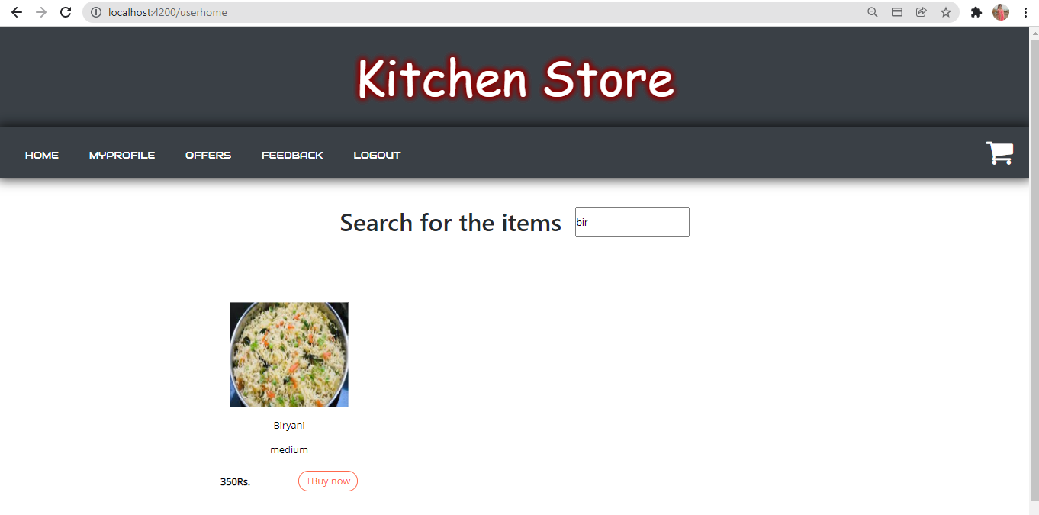

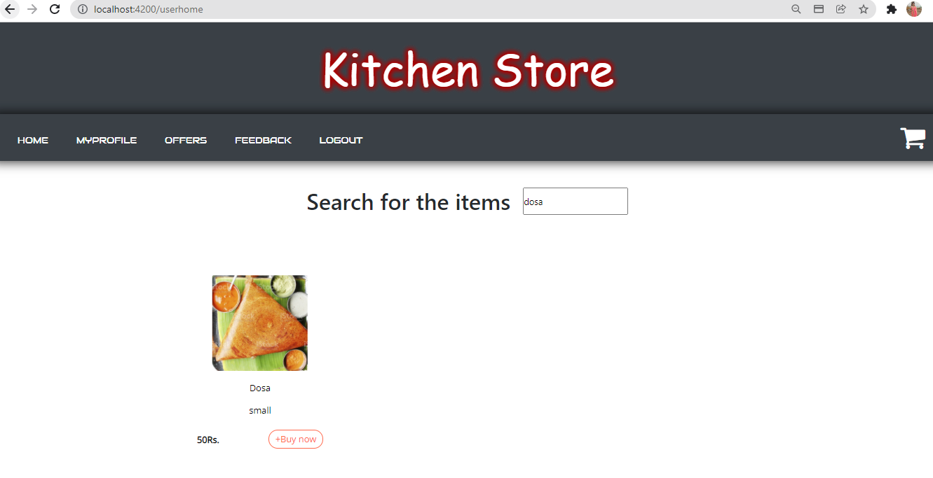

14

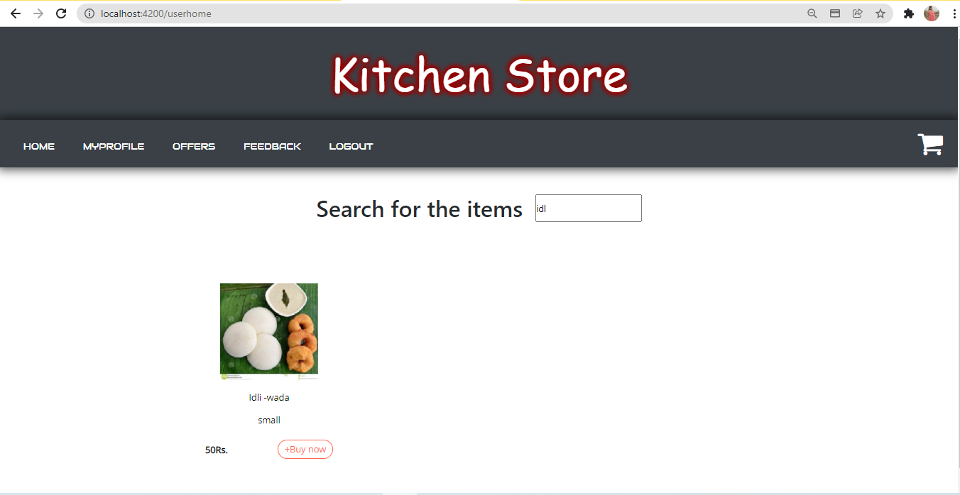
Buy Now:
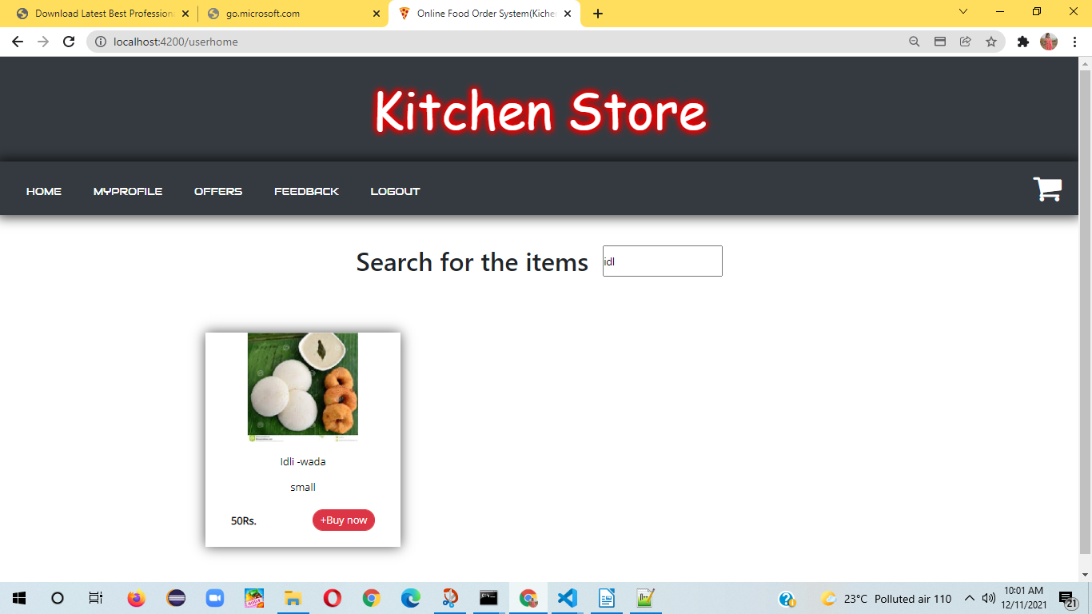

15
Go to Cart to check out:
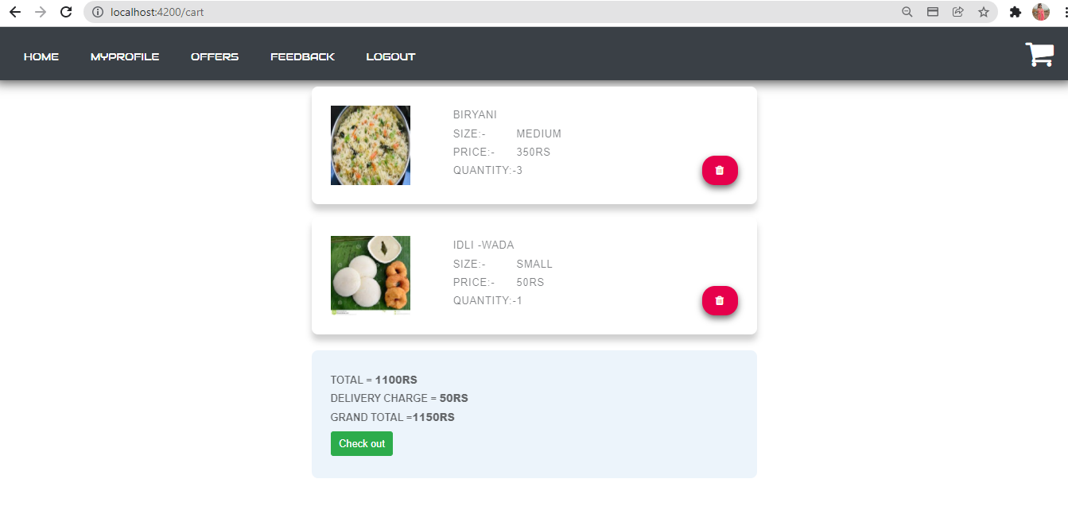

Click on check out for payment:
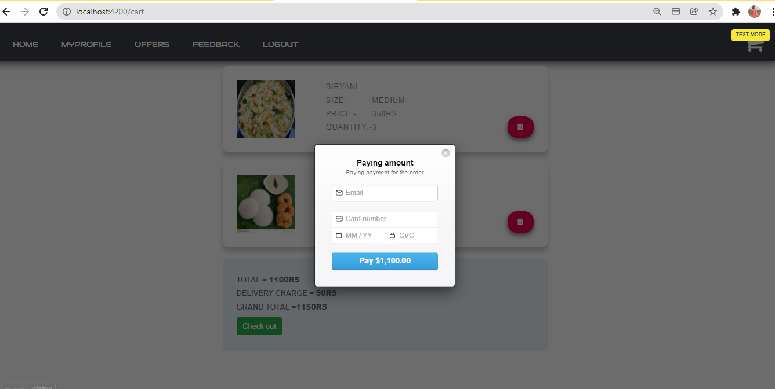

16
Provide the details (debit/credit card)
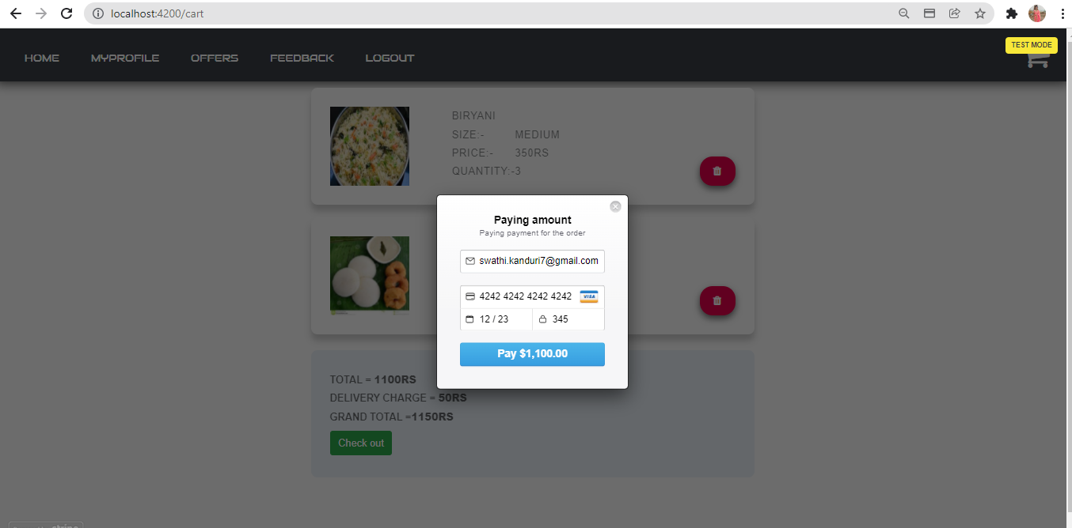

payment successful:-

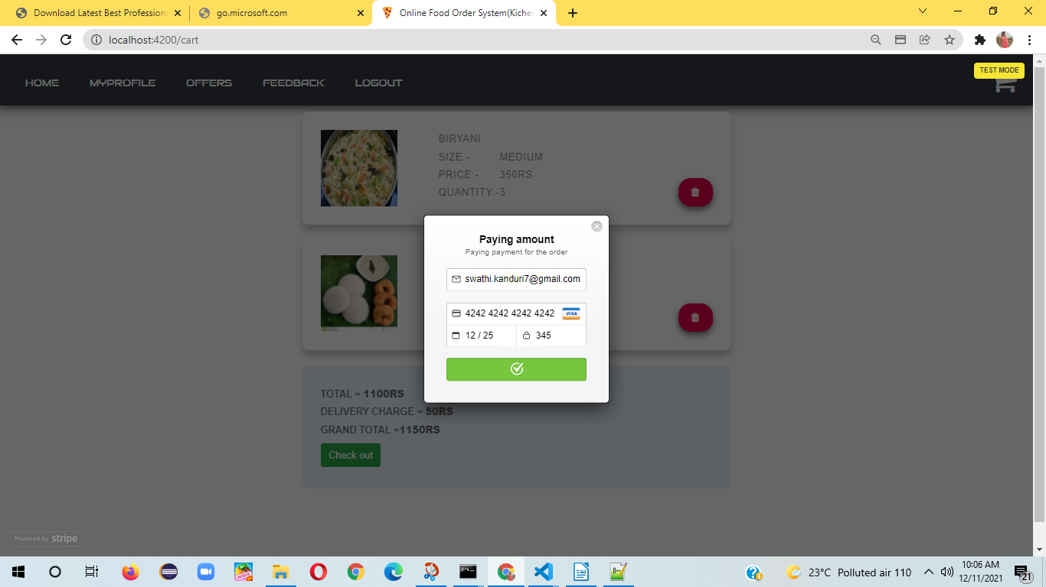
17
Placed order successfully Confirmation display:

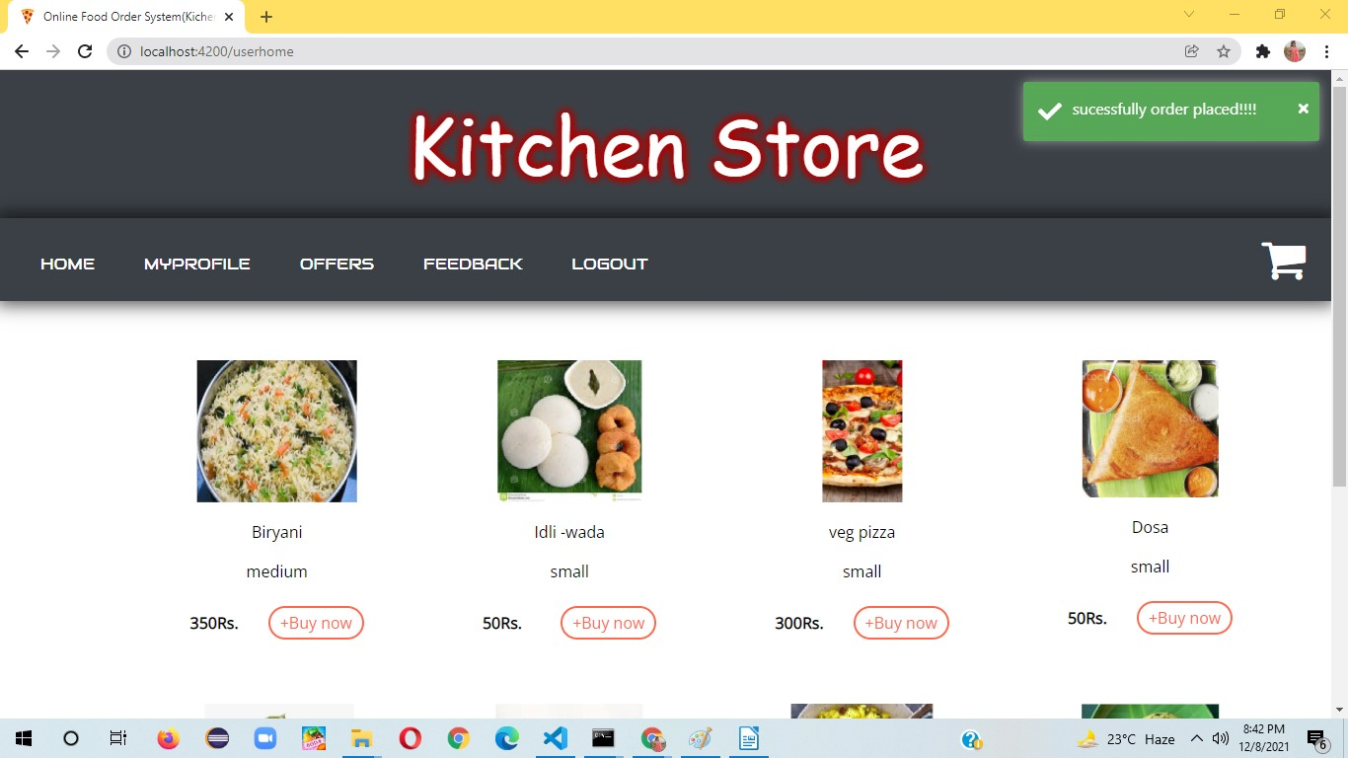

18
User Profile Settings:
Click on my profile
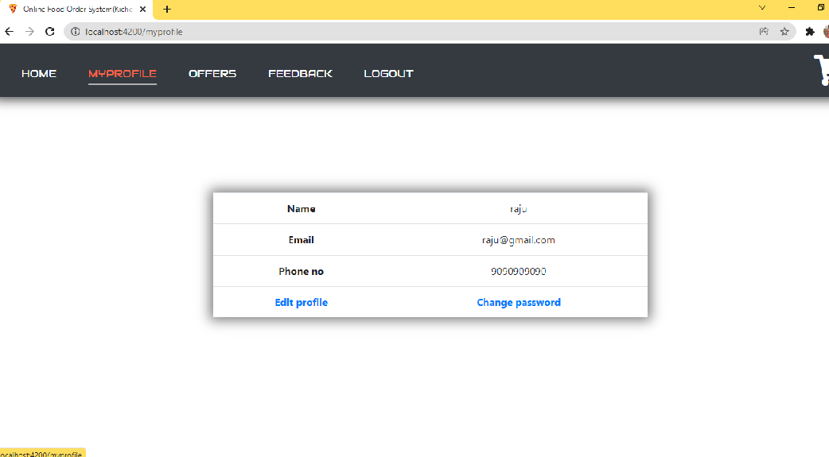
click on edit profile

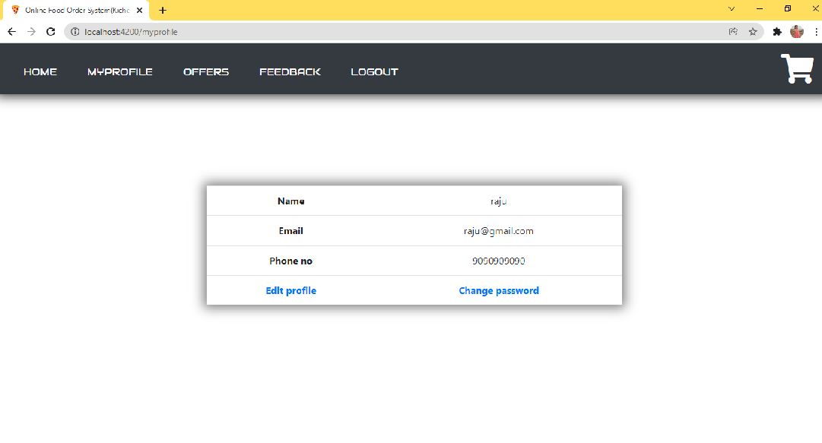
19
Edit profile
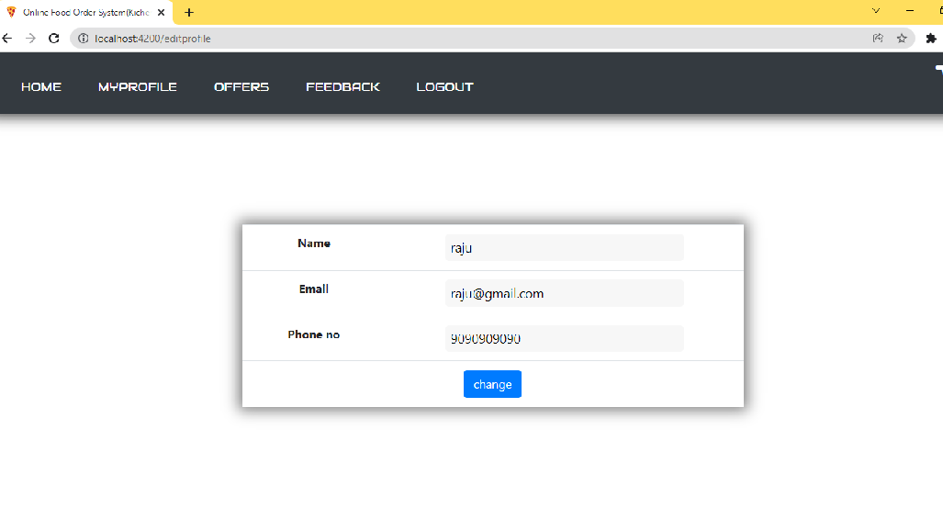
To change password
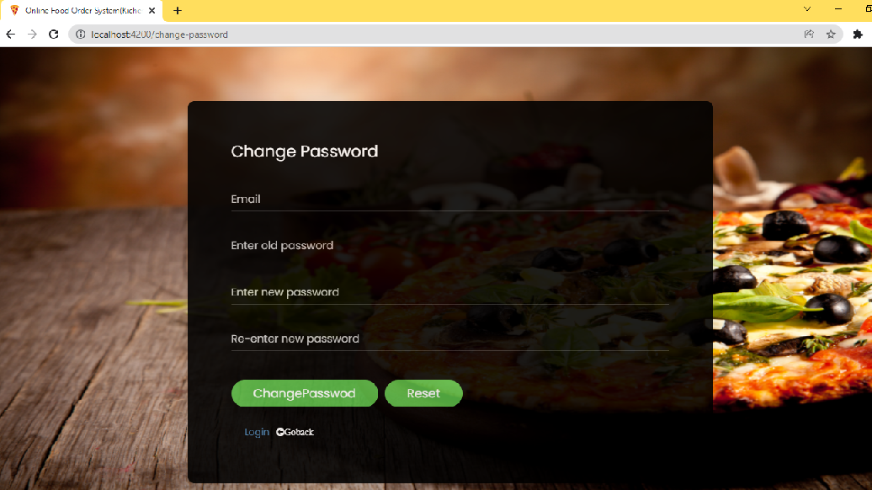

20
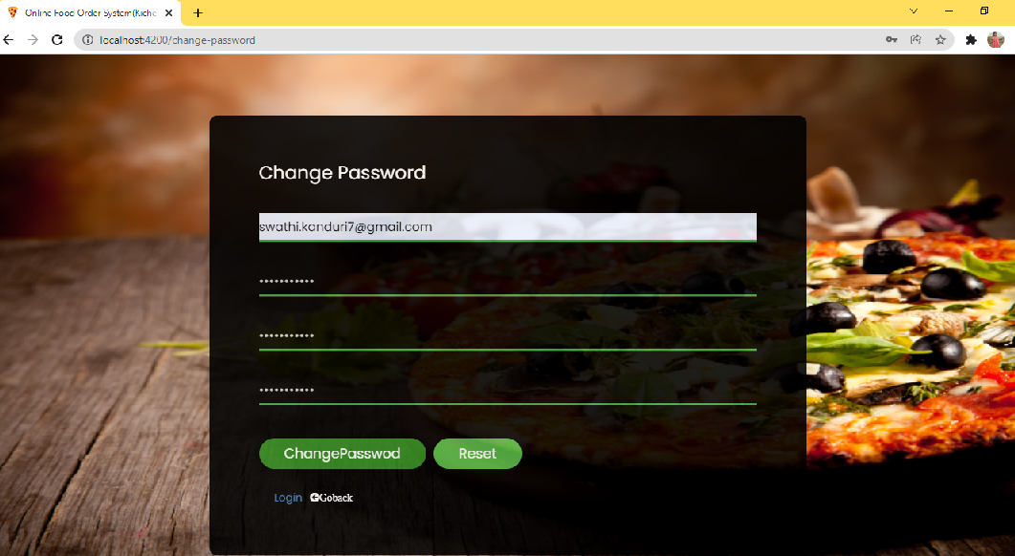

Forgot password:-
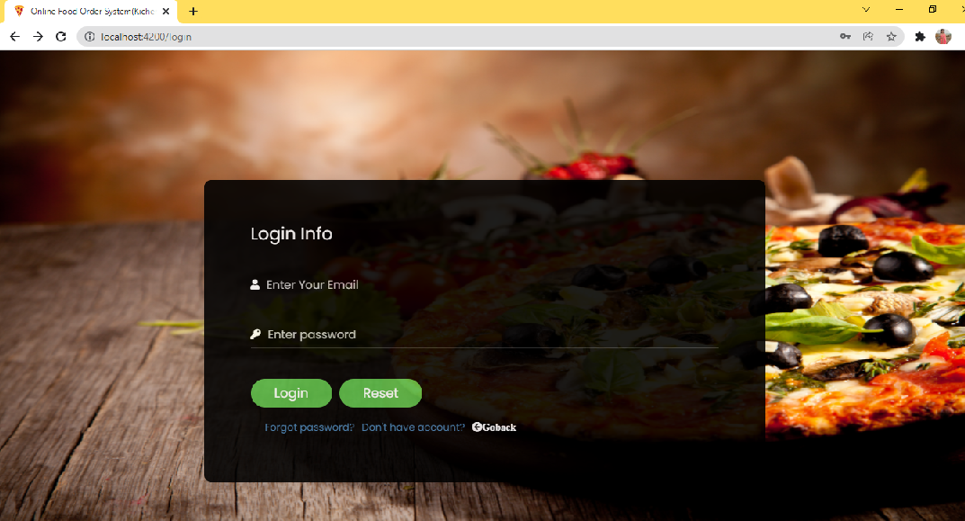

21

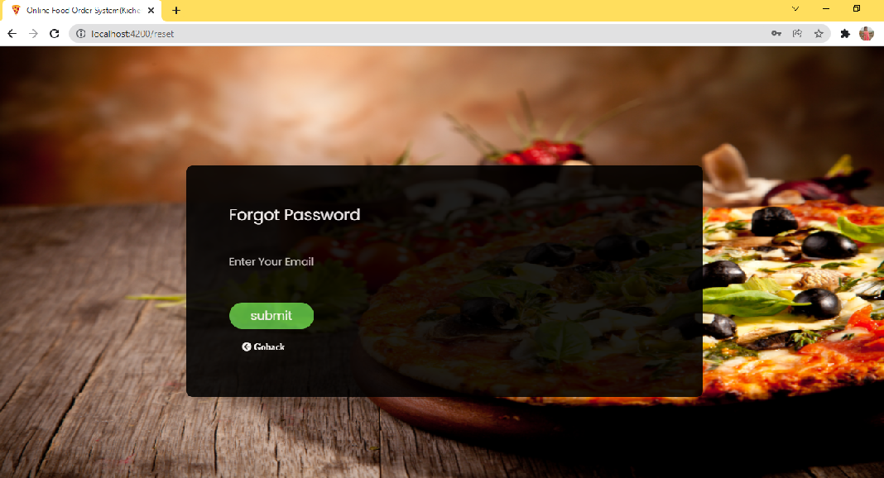
To provide Feedback:-
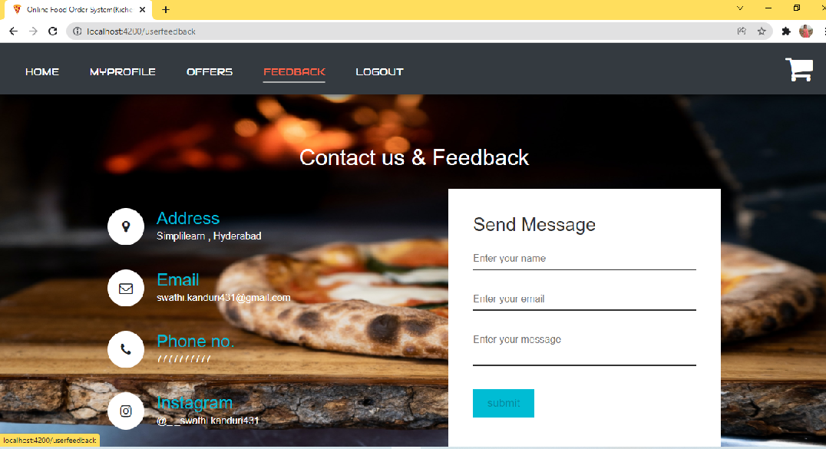

22
Contact and feedback form:-
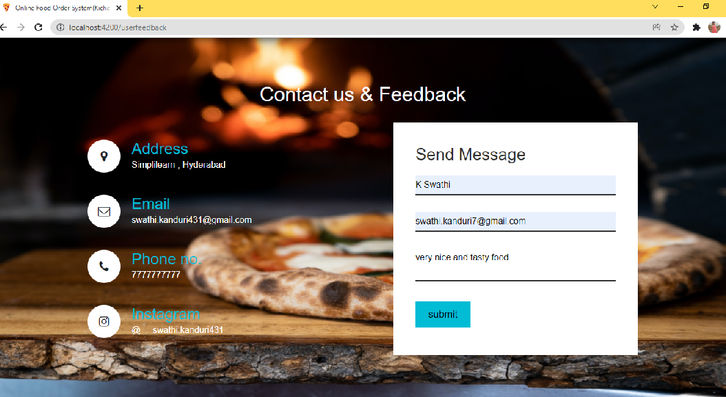
After adding feedback it will redirect to user home pabe
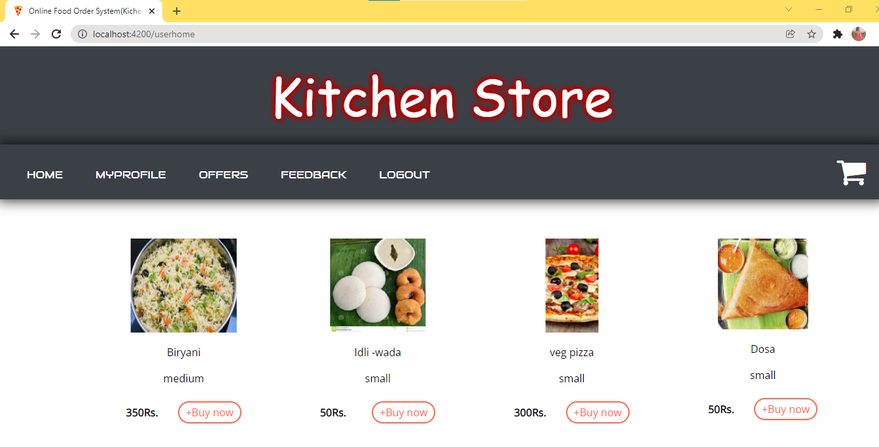

23
Logout:-
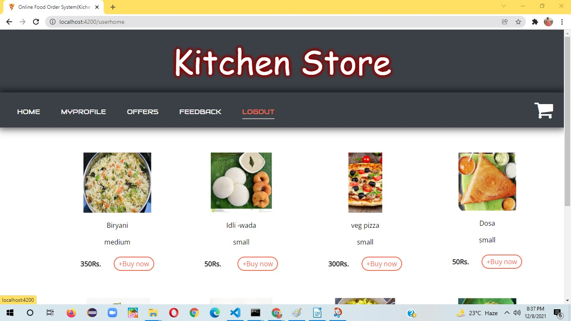

24

